Safety (Clear path Husky A300)
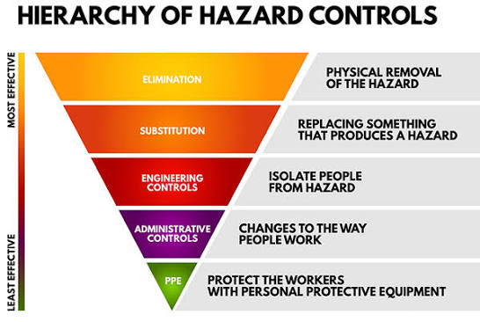
Hazard | Mitigation | Mitigation Category
Robot drives into dynamic obstacle (human, dog, car) | Clearly marked out zone with pilons/safety barriers.  Operator on standby with E-stop.  Wearing appropriate attire (no loose clothes, steel toed boots). | Elimination, Engineering Controls,  PPE
Robot drives into static obstacle | Operator on standby with E-stop.  Detection of lack of movement - robot is programmed to stop motors when within 1m of an obstacle. | Engineering Controls
Object hits robot and turns off path | Testing in controlled environment.  Clearly marked out zone with pilons/safety barriers. | Elimination, Engineering Controls.
Battery thermal runaway | Batteries are not to be charged unattended.  Battery voltage is monitored and not allowed to drop below a certain threshold | Administrative controls
Robot no longer responds to commands | Physical E-stop,  Software based runaway detection, (ie no heartbeat from base…) | Elimination,  Engineering Controls.

